**VISVESVARAYA TECHNOLOGICAL UNIVERSITY**



MINI PROJECT REPORT ON

**“ONE TRANSISTOR ELECTRONIC CODE LOCK SYSTEM”**

SUBMITTED BY:

**G VISHNU VARDHAN (1NH18EC035)**

**K PRADEEP (1NH18EC056)**

**K HEMANTH (1NH18EC050)**

**G BHAVADEEP REDDY (1NH18EC034)**

Under the guidance of

**DALIYA VK**

Senior Assistant Professor, Dept. of ECE, NHCE, Bengaluru.

# C:\Documents and Settings\Students\Local Settings\Temporary Internet Files\Content.Word\download (1).jpg

# NEW HORIZON COLLEGE OF ENGINEERING

(ISO-9001:2000 certified, Accredited by NAAC ‘A’, Autonomous college permanently affiliated to VTU)Outer Ring Road, Panathur Post, Near Marathalli, Bengaluru-560103

NEW HORIZON COLLEGE OF ENGINEERING DEPARTMENT OF ELECTRONICS AND COMMUNICATION ENGINEERING

**CERTIFICATE**

Certified that the mini project work entitled “**One Transistor Code Lock System**” carried out by **G Vishnu vardhan(1NH18EC035), K Pradeep (1NH18EC056), K Hemanth (1NH18EC050), G Bhavadeep Reddy (1NH18EC034),** Bonafede students of Electronics and Communication Department , New Horizon College of Engineering, Bangalore.

The mini project report has been approved as it satisfies the academic requirements in respect of mini project work prescribed for the said degree.

Project Guide HOD ECE

DALIYA VK Dr.SANJEEV SHARMA

**External Viva**

Name of Examiner Signature with Date

1.

2.

**ACKNOWLEDGEMENT**

The satisfaction that accompany the successful completion of any task would be, but impossible without the mention of the people who made it possible, whose constant guidance and encouragement helped us succeed.

We thank **Dr. Mohan Manghnani**, Chairman of **New Horizon Educational Institution**, for providing necessary infrastructure and creating good environment.

We also record here the constant encouragement and facilities extended to us by **Dr.Manjunatha**, Principal, NHCE and **Dr. Sanjeev Sharma**, head of the department of Electronics and Communication Engineering. We extend sincere gratitude to them.

We sincerely acknowledge the encouragement, timely help and guidance to us by our beloved guide **Daliya VK** to complete the project within stipulated time successfully.

Finally, a note of thanks to the teaching and non-teaching staff of electronics and communication department for their co-operation extended to us, who helped us directly or indirectly in this successful completion of mini project.

**G VISHNU VARDHAN (1NH18EC035)**

**K PRADEEP (1NH18EC056)**

**K HEMANTH (1NH18EC050)**

**G BHAVADEEP REDDY (1NH18EC034)**

**TABLE OF CONTENTS**

ABSTRACT

**CHAPTER 1**

INTRODUCTION…………………………………………………………………………06

**CHAPTER 2**

LITERATURE SURVEY…………………………………………………………………………………..07

**CHAPTER 3**

PROPOSED METHODOLOGY…………………………………………………………………….…..12

**CHAPTER 4**

PROJECT DESCRIPTION …… ………………………………………………..……....14

4.1 HARDWARE DESCRIPTION……………………………………………………………………………15

**CHAPTER 5**

WORKING………………………………………………………………… …………....21

**CHAPTER 6**

6.1. ADVANTAGES……………………………………………………… …………….23

6.2. DISADVANTAGES…………………………………………………………………..23

**CHAPTER 7**

RESULTS AND DISCUSSION…………………………………………… ……………24

**CHAPTER 8**

CONCLUSION AND FUTURE SCOPE …………………………………………………25

REFERENCES……………………………… …………………………………………….26

**LIST OF FIGURES**

|  |  |  |  |
| --- | --- | --- | --- |
| **SL**  **No** | **FIGURE**  **No** | **FIGURE DESCRIPTION** | **Page**  **No** |
|  |  | Block diagram of |  |
| 1 | 3.1 | PROPOSED SYSTEM | 12 |
| 2 | 5.1 | CIRCIT DIAGRAM | 22 |
| 3 | 4.1 | HARDWARE COMPONENTS | 14 |
|  |  |  |  |

### **LIST OF TABLES**

|  |  |  |  |
| --- | --- | --- | --- |
| **SL**  **No** | **Table**  **No** | **TABLE DESCRIPTION** | **Page**  **No** |
| 1 |  | NO TABLES WERE USED |  |
|  |  |  |  |

**ABSTRACT**

The idea behind ONE TRANSISTOR CODE LOCK is to control doors, lockers through a serial button code.

In this project , The principle of operation of the electronic locking system combined with a transistor: The main principle of this scheme is that the door lock is opened only by simultaneously pressing the buttons in order. If you press any parallel button, the door will lock. ... In real time, these buttons can be positioned to open the door.

By using this code lock system we can avoid theft,if we were doing any work or we went out the family member or our friends can enter in without any key and they don’t need to wait outside until we reach.And there are many such advantages with this.

**CHAPTER 01**

**INTRODUCTION**

one transistor code lock circuit which is a key coded door lock system. Earlier, we have already seen how a password based door lock system using 8051 microcontroller. For that circuit, we require programming. But, here interesting thing about this circuit is that it can be done without any programming. This circuit is simple and made up of simple transistor and buttons.

This electronic circuit is one of the simplest combination locking circuits that can be easily assembled at home. This circuit uses a single transistor and relay and has several passive components. The logic behind this circuit is also very simple. Even this scheme is simple. works great and efficient for a simple closet or shelves.

The main principle of this scheme is that the door lock opens only when the buttons are pressed in order. We can use it to lock doors and other security purposes.

**CHAPTER 02**

**LITERATURE SURVEY**

In this section we have identified and discussed existing work ,

Door lock security systems are classified based on technology used as

2.1) Password based

2.2) Biometric based

2.3) GSM based

2.4) smart card based

2.5) RFID based

2.6) Door phone based

2.7) Bluetooth based

2.8) Social networking sites based

2.9) OTP based

2.10) Motion detector based

2.11) VB based

2.12) Combined system.

**2.1** Password Based Systems The programmable electronic code lock device [1] is programmed in such a way that it will operates only with the correct entry of predefined digits. It is also called an integrated combinational type lock.

**2.3** GSM-based system

In many door lock security systems, GSM is used for the following purposes:

The purpose of communication. Purpose of the cultivated work By using the circuit as a GSM module Activated by controller to send SMSF or emergency and proper referral to the owner Security service at the time of admission. For detection When there are obstacles, the system requires various sensors. Gather It is data from the sensor and is based on your selection. With help The GSM module sends an SMS to each number. A Newly created model for door security Easy Control as GSM handheld remote control operation The set acts as a transmitter, other GSM phone sets Uses DTMF associated with the motor mounted on the door DTMF decoder, stepper motor, Microprocessor unit.

**2.4** Smart card based system

Intended security framework model is intended Allow authorized persons to obtain a safe. You will need to enter the key for a valid smart RFID card You need to ensure the passage of the door. Total control The activity is performed by the microcomputer.

**2.5** RFID based system

These types of security systems used for digital door locks uses inactive (passive) RFID tags. When In this respect, it is guaranteed that only valid people can enter Such a system works in real time and is the basis for opening Doors where the user needs to touch the label RFID detector, then input opens, Central server log data is saved as need User data. The existence and pursuit of people This is possible by using such a type of system. RFID-based gate Access the security system that indicates that it is allowed People and permits were actually created only by them K. Srinivasa al. This system Ability to minimize trained or professional human error Safe door access.

**2.6** Door Phone System

Older system, specific system Visitor identification is mainly done by Direct communication with the building set in question. Hands-free dial-up frames are created by input frames .Visitors enter through gate control Wear with the help of phone set. The latest system Based on the light videophone surveillance he is accustomed to Chau-Huang Weiet. Identifies the visitor developed by. al.. Paper used new power line communication A chip for building digital video network phones. In addition, they exchanged audio and visual information Improved the protection ability of the passage.

**2.7** Bluetooth Based Systems

Bluetooth based system is a bit like sarvy house innovations that utilizes Bluetooth function available in smart devices . The framework using Bluetooth turns out to be more simple and productive for proper utilization. Such systems are generally based on Arduino platform. The hardware of such framework is the combo of android smart phone and Bluetooth module. Arduino microcontroller here is acting as a controller and solenoid can be acting as output of locking system.

**2.8** Social Networking Sites Based Systems

A specific work, the digitalization and safety perspectives were accomplished by utilizing the phone device and web camera. The model can empower a pin to close and open a door from allotted region using SMS from a (social networking site) like Facebook, Whatsapp etc.

**2.9** OTP Based Systems

The proposed method in latest work does not need administrator‟s help to access the facility if the user knows OTP technique and has a registered mobile phone [30]. Likewise the OTP is generated and sent to the proprietor‟s mobile phone whenever user requests to access facility. Then the OTP should enter through keypad on the door [31], the door will open. In case if the mobile is not available or off then the option to open the door is to answer the security question ask by system.

**2.10** Motion Detector Based System

The Motion Detector System working is based on the principle of amount of light falling on the photodiode. At the point when the laser light is falling constantly on the photodiode, its reading is 255 in decimals. But when it’s hindered by deterrent, the voltage falls less than 50 in decimals. This flames the alarm and gives notification to the owner about the break in. And automatic lock can be activated.

**2.11** VB Based System

Electronic eye represents the model for capturing the door images with the help of microcontroller to ensure the safety for offices and houses. In this system, the image gets captured when the door is opened and these images are displayed by using VB application on computing system.

**2.12** Combined System

The locker security system is as shown in Fig 4 in view of RFID, FINGERPRINT, PASSWORD and GSM technology containing door locking frameworks which can be without much of a stretch, initiated, authenticated and validated by the authorized person. It unlocks the locker door in real time manner.

**CHAPTER 03**

**PROPOSED METHODOLOGY**

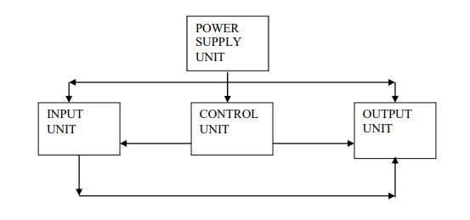

**Fig 3.1**Circuit Diagram

1.First, apply 230 V and 50 Hz input voltage to the transformer.

2.Thus, a transformer gradually reduces this voltage to 6V.

3.This low AC voltage is supplied to the bridge rectifier. This generates a pulsating direct current.

4.The output voltage of the buttons is supplied by a 2.2 kΩ resistor.

5.Now press switch S1 first and then press switch S3.

6.Now press switches S2 and S4.

7.Current now flows through these switches at the base of the transistor when the parallel buttons open.

8.The relay starts to switch and the power is connected to the motor.

9.Now you can see how the engine rotates, which means that its door lock is open.

**CHAPTER 04**

**PROJECT DESCRIPTION**

**HARDWARE REQUIREMENTS**

**TRANSFORMER**

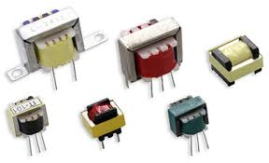

A transformer is a passive electrical device that transfers electrical energy from one electrical circuit to another or more circuits. The alternating current in any coil of the transformer creates an alternating magnetic flux in the core of the transformer, which induces an alternating electromotive force through any other coils wrapped around the same core. Electricity can be transferred between individual coils without a metal (conductive) connection between the two circuits. Faraday's law of induction, discovered in 1831, describes the effect of an induced voltage in any coil due to a change in the magnetic flux surrounding the coil.

**RESISTOR**

A resistor is a passive electrical component with two terminals that implements electrical resistance as a circuit element. In electronic circuits, resistors are used, among other things, to reduce current flow, to regulate signal levels, to separate voltages, to polarize active elements and to terminate transmission lines.

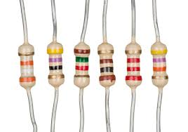

**BRIDGE RECTIFIER**

When an alternating current signal is applied through the bridge rectifier, during the positive half-cycle, terminal A becomes positive and terminal B becomes negative. This causes the diodes D1 and D3 to be polarized forward and D2 and D4 in the opposite direction.

The current flow during the positive half-cycle is shown in the figure below:

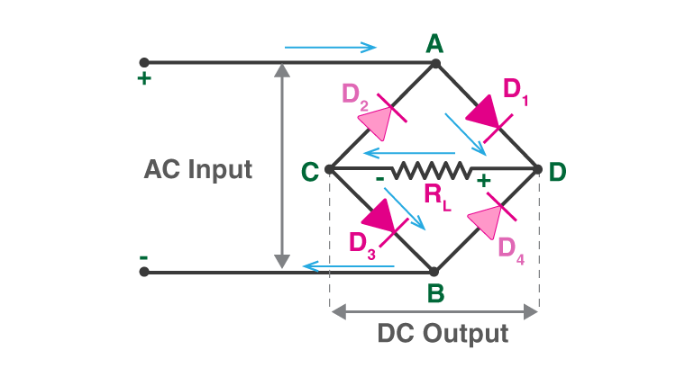

**RELAY**

The relay is an electrically operated switch. It consists of a set of input terminals for one or more control signals and a set of working contact terminals. A switch can have any number of contacts in several forms of contact, such as normally open contacts, normally open contacts, or combinations.

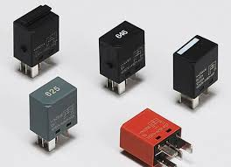

**AC SOURCE**

Alternating current (AC) is an electric current that periodically changes direction and changes in magnitude continuously over time, unlike direct current (DC), which flows in one direction only.

Alternating current is the form in which electricity is supplied to businesses and homes and is the form of electricity that consumers typically use when plugging kitchen appliances, televisions, fans and light bulbs into an outlet.

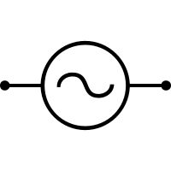

**CAPACITOR**

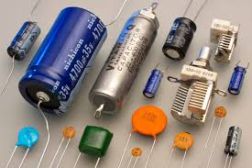

A capacitor is a device that stores electricity in an electric field. It is a 2-terminal passive electronic component.

The effect of a capacitor is known as capacitance. Capacitors are components designed to add capacitance to the circuit, although there is a constant capacitance between two nearby conductors in the circuit. Capacitors were originally known as capacitors or capacitors.This name and its annexes are still widely used in many languages, but are rarely used in English. However, condenser microphones are also called condenser microphones.

**TRANSISTOR**

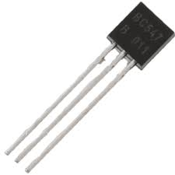

Transistors are semiconductor devices used to amplify or switch between electronic signals and power. It usually consists of a semiconductor material with at least three terminals for connecting to external circuits. The voltage or current applied to a pair of transistor terminals controls the current flowing through the other pair of terminals. The control (output) power can be greater than the control (input) power, so the transistor can amplify the signal. Currently, some transistors are individually packaged, but more transistors are built into integrated circuits.

**MOTOR**

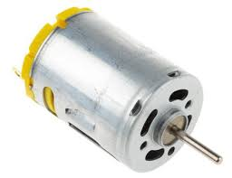

An electric motor is an electric machine that converts electrical energy into mechanical energy. Most electric motors work by interacting with the magnetic field of the motor and the current in the coil of the wire to generate the torque force applied to the motor shaft. Electric motors can be powered from direct current (DC) sources such as batteries, vehicles and rectifiers, or alternating current (AC) sources such as mains, inverters and generators. A generator is mechanically the same as an electric motor, but it operates with a backflow of energy and converts mechanical energy into electricity.

**DIODE**

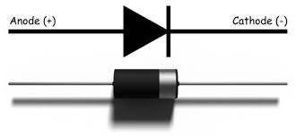

A diode is an electronic component that mainly has two terminals that conduct current in one direction (asymmetric conductance). There is a low resistance in one direction (ideally zero) and a high resistance in the other direction (ideally infinite). A vacuum tube with a diode or thermionic diode is a tube with two electrodes, a heated cathode and a plate, allowing electrons to flow from the cathode to the plate in one direction.

**CHAPTER 05**

**WORKING**

The circuit consists of a gradual transformer, whose input is supplied with alternating current of 230 V and 50 Hz. In a descending transformer, the number of primary windings is less than the number of secondary windings.

It is connected to a bridge rectifier. The bridge rectifier rectifies the entire wavelength of the transformer. It has 4 contacts, two of which are connected to a transformer. The other two pins have one connected to ground and the other to a resistor and capacitor.

The other end of the capacitor is grounded. Four buttons S1, S2, S3 and S4 are connected in series from the resistor. Now, from the next S5 button, they are connected in parallel. Thus, S5, S6, S7 are connected in parallel.

A 100kΩ resistor is connected in parallel with the buttons. The base of the transistor is connected to the buttons in parallel. The emitter terminal of the transistor is connected to ground. Collector pin connected to diode 1N4007, relay. The other end of the diode connects to one end of the relay.

Here the diode is used to protect the transistor, as the relay emits EMF. The relay has five contacts. One pin connects to the positive terminal of the diode. The other pin is connected to ground. Thus, the output of the relay is connected to the motor via its alternating current source.

The relay used here is a magnetic relay. It has five contacts, ie NC, NO, COM, A, B. A, B are the coil inputs. When no voltage is applied to these pins, the COM pin connects to a normally closed contact, ie an NC contact. When DC voltage is applied to contacts A, B of the relay, the COM contact connects to the normally open contact, ie the normally open contact of the relay.

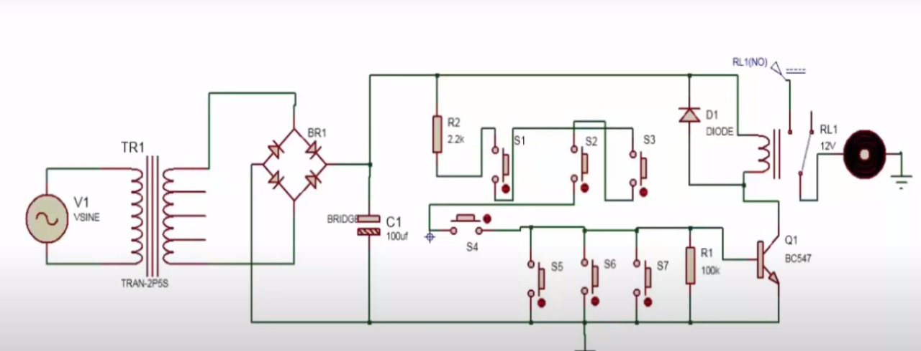

**CHAPTER 06**

**ADVANTAGES**

This circuit is very simple, reliable and cheap.

We can use it in security applications.

We can also use it in door locking systems to open the door.

**DISADVANTAGES**

If the user has forgotten the password, ie the order of pressing the buttons, the lock will be difficult to open.

**CHAPTER 07**

**RESULT AND DISCUSSION**

**DISCUSSION**

In correctly connecting the line wires to buffers A, B, C and D, as shown in the electronic combination lock circuit diagram. For a clear understanding, the example may be more attractive. If the code is 1234, connect line 1 to A, line 2 to B, line 3 to C, line 4 to D, and connect the remaining lines 6, 7, 8, 9 to the reset panel as shown in the dotted lines. on the corresponding circuit diagrame electronic combination lock circuit, the lock code is set by us

The entire combined electronic lock circuit is built on two microcircuits of the double flip-flop CD4013 (IC1 and IC2). The synchronization pins of the four flip-flops are connected directly to the contact plates A, B, C and D. The condition for starting the relay RL1 in the circuit is met by the synchronization points A, B, C and D in this order.

**RESULT**

The project has successfully done and the expected outcome has been seen

**CHAPTER 08**

**8.1 CONCLUSION AND FUTURE SCOPE**

**CONCLUSION:**

The rising rate of crime, attacks by thieves, intruders and vandals, despite all forms of security devices and locks, continues to require the attention of researchers to find a permanent solution to the problem of human well-being and property.

**FUTURE SCOPE**

In future we can write code for this and by doing code we can get a hint or OTP to the register mobile so that it easy to open the door

**8.2 REFERENCES**

[1]. Tan, Lee and Soh – “Internet based Monitoring of Distributed Control Systems”, - Energy and power Engineering. Publisher: IEEE Transactions on Education, Place: New Jersey, Country: USA, Year: 2002, Vol: 45, Iss. No. 2., pp. 128-134.

[2]. Potamitis, I., Georgila, K. Fakotakis, N., & Kokkinakis, G – ‘An Integrated system for smarthome control of appliances based on remote speech interaction’,- 8 th European conference on speech and communication technology, Publisher: World Journal control science and Engineering, Place: Geneva, Country: Switzerland, Year: 2003, Vol. No: 2, Iss. No.1, pp. 2197-2200.

[3]. S. M. Anamul Haque, S. M. Kamruzzaman and Md. Ashraful Islam – ‘A System for SmartHome Control of Appliances Based on Time and Speech Interaction’,- Proceedings of 4th International Conference on Electrical Engineering, Place: Bhubaneshwar, Country: India, Year:2006., pp.128 to 131.

[4]. N. P Jawarkar, V. Ahmed, S.A. Ladhake, and R.D Thakare – ‘Micocontroller based Remote monitoring using mobile phone through spoken commands’,- Journal of networks, Publisher: World Journal control science and engineering, Place: Lagos, Country: Nigeria, Year:2008, Vol. No.:3, Iss. No.2, pp.58 to 83.

**REFFERENCE WEBSITES**

<https://www.electronicshub.org/one-transistor-electronic-code-lock-system/>

<https://www.circuitstoday.com/one-transistor-code-lock>

<https://www.eeweb.com/electronic-code-lock-using-single-transistor/>

<https://www.scribd.com/document/336912223/Electronics-Code-Lock-Using-One-Transistor>